Exercise 5: Configuring the Spring IoC Container
Scenario:
The library management application requires a central configuration for beans and dependencies.
Implementation:
- Create Spring Configuration File:

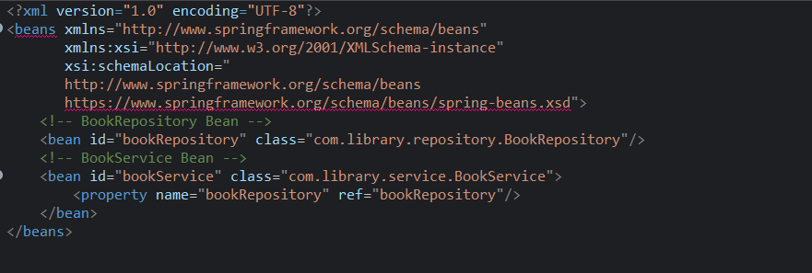

- Update the BookService Class:

BookRepository.java

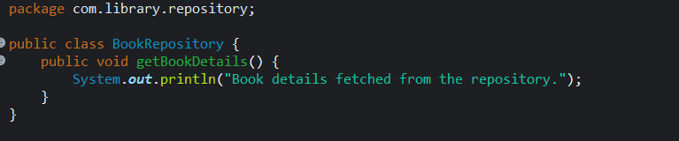

BookService.java

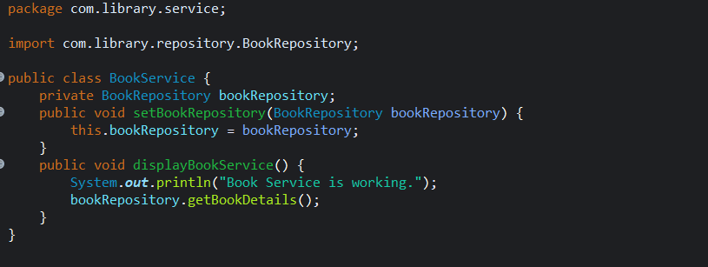

- Run the Application:
LibraryApplication.java

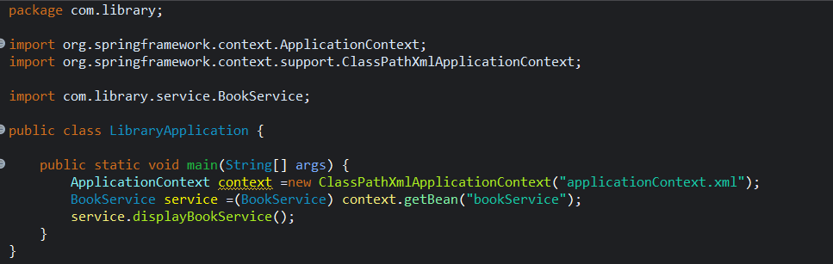

OUTPUT:
